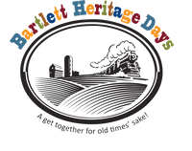
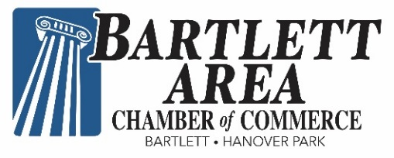
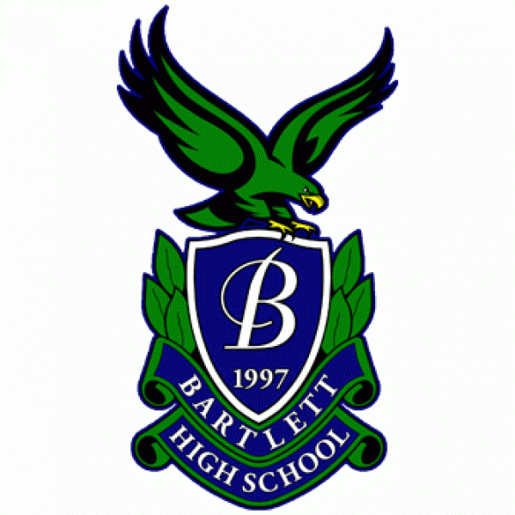

BINGO is BACK in Bartlett!
Please support the Chamber - BHS Booster Club partnership in the BINGO Tent
at Bartlett’s Heritage Days!!
When: Saturday, September 10, Noon – 6 p.m.
Sunday, September 11, Noon – 5 p.m.
Where: Banbury Fair, 211 W Railroad Ave, Bartlett
What: Bingo - $1 per card or $5 for 6 cards
New cards each game!
- BINGO (Must be 18 to play) ● Cash Bar
Open to all – Community support welcome and encouraged!
Proceeds will benefit Chamber of Commerce programs, services and scholarship and the Bartlett High School Booster Club’s academic, athletic, fine arts and extracurricular activities. For information, contact Mary@bartlettareachamber.com or treasurer@bhsboosters.org.
