
Win Big Bucks
at BHS Booster’s
Bingo Night!
When: Saturday, March 5, 6:15-10:30 p.m.
First game begins 6:30 p.m. Free admission!
Where: Fire Barn, 218 S. Main St., Bartlett
What: Bingo – $1 per card or $5 for 6 cards
New cards each game!
• Bingo (Must be 18 to play) •
• 50/50 raffle • Cash Bar •
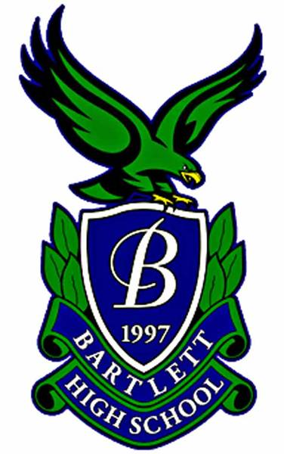
Open to all; community support
welcome and encouraged!
All proceeds will benefit the Bartlett High School Booster Club, an
Illinois Not-For-Profit Corporation. The Club is an organization of parents, teachers, administrators, and community members who serve as a support organization for all Individual Activity Groups encompassing academic, athletic, fine arts and all other extracurricular activities at Bartlett High School.
For information, contact treasurer@bhsboosters.org

