An Evening of the Spoken Word with Russ Devereaux
$5 Friday, November 13, 2015
7 p.m.
Arts in Bartlett Center for the Arts,
215 S. Main Street
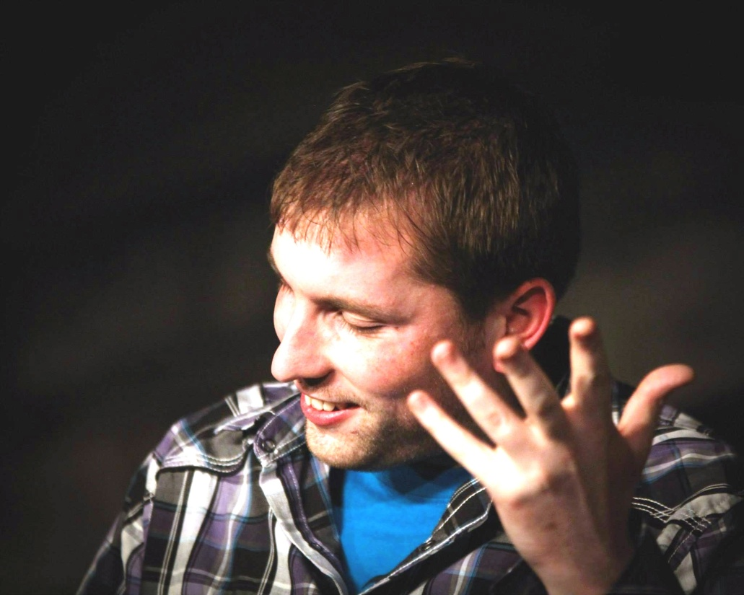

Enjoy an evening of performance by Russ Devereaux,
slam poet and playwright who creates stories of social justice and personal trial incorporating drama, humor and wit.
Snacks and drinks provided. Open to the public.
arts@artsinbartlett.org; (630)-372-4152

